МІНІСТЕРСТВО ОСВІТИ І НАУКИ УКРАЇНИ
НАЦИОНАЛЬНА МЕТАЛЛУРГІЙНА АКАДЕМІЯ УКРАЇНИ

І. П. НІКІТІНА, Т. В.КИРПИТА, В. В. БОЯРКІН

ENGLISH FOR METAL FORMING ENGINEERING

Друкується за Планом видань навчальної та методичної літератури,

затвердженим Вченою радою НМетАУ

Протокол № 1 від 26.01.2019

Дніпро НМетАУ 2019

УДК 811.111(075):621.77

І. П. Нікітіна, Т. В. Кирпита, В. В. Бояркін English For Metal Forming Engineering. Навчальний посібник. – Дніпро: НМетАУ, 2019. – 43 с.

Містить основні навчальні матеріали з дисципліни «Іноземна мова професійного спрямування» для студентів, що навчаються за спеціалізацією «Обробка металів тиском». Призначено для поглиблення знань, набутих при вивченні базового курсу з англійської мови.

Пропонуються тексти на основі спеціальної термінології, а також вправи, спрямовані на розвиток навичок усного та писемного мовлення.

Призначений для студентів спеціальності 136 – металургія (магістерський рівень)

Іл. 18. Бібліогр.: 8 найм.

Друкується за авторською редакцією.

Відповідальний за випуск В.В. Прутчикова, канд. філ. наук, доц.

Рецензенти: Н.А.Сафонова, канд. філол. наук, доц. (ДНУ ім. О.Гончара)

Н.Т.Махоніна, канд. філол. наук, доц. (ДНУ ім. О.Гончара)

© Національна металургійна академія
України, 2019

© Нікітіна І. П., Кирпита Т. В.,

Бояркін В. В., 2019

ВСТУП

Навчальний посібник “English for Metal Forming Engineering” для студентів спеціальності 136 – металургія (магістерський рівень) укладено з метою поглиблення знань студентів з іноземної мови (англійська) у галузі, лексики та граматики на матеріалі автентичних текстів професійної тематики, що сприятиме розвитку їх соціолінгвістичної та лінгвістичної компетенцій.
Відповідно до Програми навчальної дисципліни «Іноземна мова професійного спрямування», навчальний посібник структурований вісьмома змістовими частинами:

- Unit 1. ENGINEERING - WHAT’S IT ALL ABOUT?
- Unit 2. FORMING, WORKING AND HEAT-TREATING METAL
- Unit 3. LOAD, STRESS AND STRAIN
- Unit 4. FORCE, DEFORMATION AND FAILURE
- Unit 5. METAL FORMING PROCESSES
- Unit 6. METAL FORMING OPERATIONS. CLASSIFICATION
- Unit 7 METAL FORMING OPERATIONS. BRIEF DESCRIPTION OF FORMING OPERATIONS
- Unit 8. ROLLING MILL PRACTICE

Усі змістові частини містять необхідний лексичний мінімум, лексико-граматичні вправи, автентичні тексти з професійної тематики, комунікативні вправи, спрямовані на розвиток усного та писемного мовлення.
Навчальний посібник містить додатки – лексичний мінімум зі спеціальності, довідковий матеріал, що сприяє розвитку навичок професійно-орієнтованого мовлення та знімає лексичні труднощі при роботі з текстами.

UNIT 1
ENGINEERING - WHAT’S IT ALL ABOUT?

A. List the main branches of engineering. Combine your list with others in your group. Then read this text to find out how many of the branches listed are mentioned.
Engineering is largely a practical activity. It is about putting ideas into action. Civil engineering is concerned with making bridges, roads, airports, etc. Mechanical engineering deals with the design and manufacture of tools and machines. Electrical engineering is about the generation and distribution of electricity and its many applications. Electronic engineering is concerned with components and equipment for communications, computing, and so on.
Mechanical engineering includes marine, automobile, aeronautical, heating and ventilating, and others. Electrical engineering includes electricity generating, electrical installation, lighting, etc. Mining and medical engineering belong partly to mechanical and partly to electrical.

B. Study these illustrations. They show some of the areas in which engineers work. What kinds of engineers are concerned with these areas?

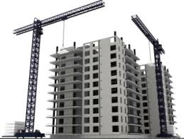 | 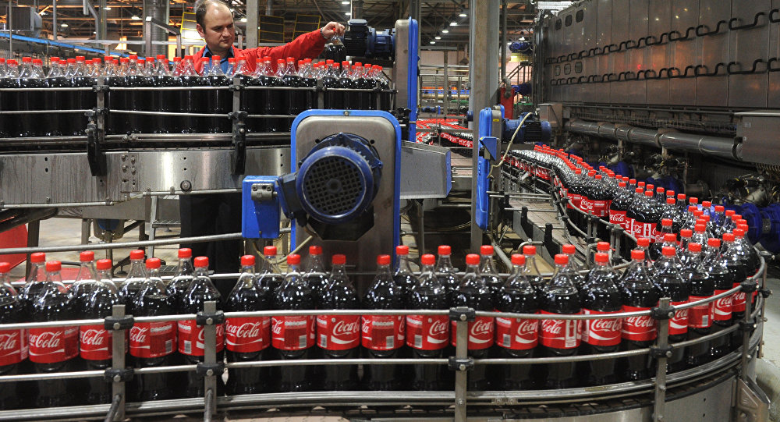
 | 

B Transport: Cars, trains, ships, and planes are all products of mechanical engineering. Mechanical engineers are also involved in support services such as roads, rail track, harbours, and bridges.
Food processing: Mechanical engineers design, develop and make the machines and processing equipment for harvesting, preparing and preserving the foods and drinks that fill the supermarkets.
Medical engineering: Body scanners, X-ray machines, life-support systems, and other high-tech equipment result from mechanical and electrical engineers combining with medical experts to convert ideas into life-saving and preserving products.
Building services: Electrical engineers provide all the services we need in our homes and places of work, including lighting, heating, ventilation, air-conditioning, refrigeration, and lifts.
Energy and power: Electrical engineers are concerned with the production and distribution of electricity to homes, offices, industry, hospitals, colleges and schools, and the installation and maintenance of the equipment involved in these processes.

C. Language study deals with/is concerned with
What is the link between column A and column B?
A | B
mechanical  electrical | machines  electricity
Column A lists a branch of engineering or a type of engineer. Column B lists things they are concerned with. We can show the link between them in a number of ways:
1. Mechanical engineering deals with machines.
2. Mechanical engineers deal with machines.
3. Mechanical engineering is concerned with machines.
4. Mechanical engineers are concerned with machines.
5. Machines are concerned with mechanical engineers.
Match each item in column A with an appropriate item from Column B and link the two in a sentence.
A | B
1. marine  2. aeronautical  3. heating and ventilating  4. electricity generating  5. automobile  6. civil  7. electronic  8. electrical installation  9. medical | a) air-conditioning  b) roads and bridges  c) body scanners  d) cables and switchgear  e) communications and equipment  f) ships  g) planes  h) cars and trucks  i) power stations

Over to you
Fill in the gaps in the following description of the different branches of engineering using information and language you have studied in this unit.

The main branches of engineering are civil, ________ , _______ and electronic. Mechanical engineering is _________ ________ machinery of all kinds. This ranch of engineering includes _________, automobile, _________, and heating and ventilating. The first three are concerned with transport: _______, _______, cars and planes. The last _______ with air-conditioning, refrigeration, etc.
Electrical engineering deals with ________ from generation to use. Electricity generating is concerned with ________ stations. Electrical installation deals _______ cables, switchgear, and connecting up electrical equipment.
Two branches of engineering include both _______ and _______ engineers. These are mining and _________ engineering. The former deals with mines and mining equipment, the latter with hospital ________ _________ of all kinfs.

UNIT 2

FORMING, WORKING AND HEAT-TREATING METAL
A: Casting, sintering and extruding metal
Metal can be formed into shapes using heat and pressure. Casting involves heating metal until it becomes molten (liquid) and pouring it, or forcing it under pressure, into a mould called a die. Instead of being cast, metal components can be formed by sintering. This is done by using metal powder instead of molten metal. The powder is placed in a die and compressed into a solid mass. It is then heated (though not melted) until it becomes sintered that is, the powder particles join together structurally, due to the heat.
Metal can also be shaped by extruding it into long lengths. Extrusion involves heating metal until it is molten, then forcing it at high pressure through a shaping tool also called a die to form bars or tubes, for example. At the same time, the metal cools and becomes solid.
B: Working metal
Traditionally, many metal tools were made by heating iron bars in a fire, called a forge, until they were red hot or (hotter still) white hot. The metal was then worked - in other words, shaped by hammering it. Working metal using pressure (for example, hammering) is also called forging. The same basic technique is still in use today, especially with steel. However, large, automated machines are now used. Metal is often worked (or forged) when hot (hot forged), but may also be worked when it is cold (cold forged).
A common forging technique is drop forging, where a heavy hammer is dropped onto a piece of metal. A die fixed to the hammer compresses the metal into the required shape. Rollers can also be used to apply compression, with or without heat, to produce hot rolled or cold rolled metal.
Forging also increases the hardness of metal. This is called work hardening. Metal becomes work hardened because its structure is changed by compression. The same result can be achieved without hammering or rolling and therefore without changing the component’s shape – by shot-peening. This involves firing small metal balls (metal shot) at the surface of components (when cold), at high speed. After components have been shot-peened, their surface is significantly harder.
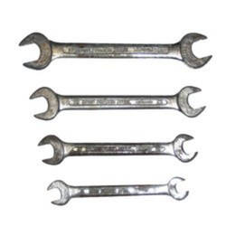
C: Heat treating metal
Drop forged steel

The properties of a metal can be changed by heat treating it – that is, heating and cooling the metal. The table below, from the technical information section of a steel supplier’s website, summarizes the main types of heat treatment.

Type of heat treatment | Description of process | Properties of treated metal
quenching | Metal is heated, and then dipped in water or oil to cool it rapidly. | Quenched metal is harder, but tends to be more brittle.
annealing | Metal is heated, and then allowed to cool slowly. | Annealed metal is generally softer and more elastic.
tempering | Metal is heated and kept at a high temperature for a period of time. | Tempered metal possesses a balance between hardness and elasticity.
precipitation hardening  (also called age hardening) | A process similar to tempering, but heat is maintained for longer. | Precipitation-hardened metal is harder than tempered metal.
case hardening (also  called surface hardening) | Metal is heated in specific types of gas (not in air), causing its surface to absorb elements such as carbon. | Only the outer surface of case-hardened metal becomes harder.
TASKS
2.1 Tick what is usually required in the metal forming processes (1-3). Look at text A to help you.

 | molten metal | metal powder | heat | pressure | a die
1. casting | □ | □ | □ | □ | □
2. sintering | □ | □ | □ | □ | □
3. extrusion | □ | □ | □ | □ | □

2.2. Decide whether the sentences below are true or false, and correct the false sentences. Look at text B to help you.
- Metal must always be heated before it can be forged.
- When referring to metals, the terms working and forging mean the same.
- A common reason for forging metal is to increase its hardness.
- One way of forging metal is by heating it and then rolling it.
- Metal can only be rolled after it has been heated to a high temperature.
- When metal is drop forged, it is subjected to compression.
- Metal can only be work hardened by the process of hot forging.
- Shot-peening is a hot forging technique used to work hardened metal.

2.3. Make correct sentences using one part from each column. Look at text C to help you.
1. If a metal is precipitation hardened, | it is held at a high temperature for a time, | making it harder, but more brittle.
2. When metal is annealed, | it is heated within a gas | to improve its hardness without reducing its elasticity too much.
3. If metal is quenched, this means | it can also be described as age hardened, | to harden only the metal near the surface.
4. When a metal is tempered, | its temperature is allowed to decrease gradually | because it is heated for a long time.
5. If a metal case is hardened, | its temperature is reduced rapidly | in order to make it more elastic and less brittle.
2.4. Replace the underlined expressions in the report extract with alternative words and expressions from texts A, B and C. Sometimes there is more than one possible answer.
The first stage in manufacturing the blades for the cutting tools is to form them into an approximate shape by (1) a process of squeezing molten metal through a die. Before the blades have cooled, they are then (2) hammered while still at a high temperature – a process which not only flattens them into their final shape, but also ensures the metal becomes (3) harder as a result of the hammering action. The blades are then (4) cooled quickly in water. Finally, they are (5) bombarded with small metal balls in order to further increase their surface hardness.

Over to you
Think of a type of steel component that needs to have specific properties. Suggest different ways of obtaining these properties by forging or heat treating the steel.

UNIT 3

LOAD, STRESS AND STRAIN
A: Load
When engineers design a machine or structure, they need to know what forces will be exerted on it (put pressure on it). In engineering, forces are called loads. Usually, several different loads will act on – apply force to – the components in a machine, or the members (parts) of a structure. A component or member which is designed to carry (or bear) a load is called a load-bearing component or member.
To predict what will happen when components are loaded, engineers calculate the magnitude (size) of each load, and also work out the direction of the load – for example, vertically downwards. Load is therefore a vector quantity (or vector) – that is, a measurement with both a magnitude and a direction. This is different to a scalar quantity, which has a magnitude only.

Types of load

Type of load | Description | Examples
dead load | a load that never changes, such as the self-weight of a structure (its own weight) | the weight of the concrete from which a bridge is built
live load | a load whose magnitude can be different at different times – usually imposed on (put on) a machine or structure by something that is not part of the machine or structure | cargo carried by a truck – different weights of cargo may be carried on  different trips
static load | a load that remains still (does not move) | The dead load of a building, or a live load which remains still, such as snow lying on a roof
dynamic load | a moving load, such as one which produces a sudden shock but lasts for only a brief moment (an impulse) | aircraft wheels hitting the runway on landing
point load | a load which is concentrated – that is, one which acts on a small area | the end of a set screw pressing on a shaft
uniformly distributed load (UDL) | a load which is spread evenly over a reasonably large area | the weight of water acting on the bottom of a swimming pool

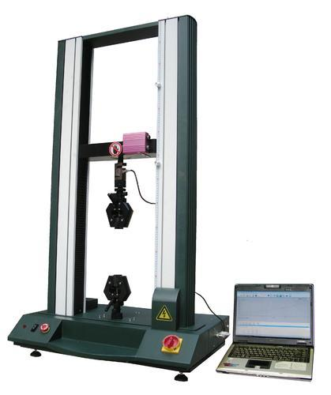
B: Stress and strain
The extract below is from an engineering textbook.
In a test, a thick cable is used to pick up a heavy object. The cable stretches slightly, but lifts the weight. A second test is done using a thinner cable – one with only half the cross-sectional area of the thick cable. This time, the cable stretches, and then breaks.
Why did the thinner cable fail? Not due to a higher load, as the weight was the same. The failure was due to stress. Stress is force per unit of area, and is measured in newtons per square metre, or Pascals (1 N/m2 = 1 Pa). The thinner cable was therefore stressed twice as much as the thick cable, as the same load was concentrated into a cross-sectional area that was 50% smaller.
Why did the thick cable stretch but not break? When objects are stressed, they deform – that is, they change size (if only slightly). In the tests, the cable extended- it increased in length. Extension can be measured as a change in an object's length compared with its original length before stress was applied. This measurement is called strain. According to a law called Young's Modulus of Elasticity, stress is proportional to strain. In other words, a percentage increase in stress will cause the same percentage increase in strain. However, this is only true up to a point called the limit of proportionality. If a material is overstressed - beyond this limit - it will start to become strained by a higher proportion. Stress and strain will therefore become disproportional.

TASKS
3.1. Replace the underlined words and expressions with alternative words and expressions from Text A and the Types of Load table.
If you look at the objects around you, it's difficult to find something that couldn't be smashed with a hammer. But if you laid a hammer down carefully on any of those objects, the (1) force which it (2) put on them wouldn't be sufficient to cause even the slightest damage. This comparison illustrates the difference between:
- a (3) moving force, which combines mass and movement to apply (4) a shock
- a (5) still force, which consists only of an object's (6) own mass.
Between the two situations, the (7) size of the load (8) placed on the surface is dramatically different.
The above comparison illustrates another difference in the way surfaces are (9) pressured. When a hammer is laid horizontally on a surface, its weight is spread over a relatively large area. It therefore applies a (10) spread out force. By contrast, when a hammer hits something, only the edge of the hammer head comes into contact with the surface. The force is therefore (11) focused in a small area, applying a (12) localized pressure.

3.2. Complete the technical checklist (1-7) based on the questions (a-g), using words from texts A and B and the Types of Load table. The first one has been done for you.

a) Which components need to carry load?
b) What types of load will be carried by each part? Which loads will remain constant, and which will differ depending on use and circumstances?
c) What amount of load will be exerted, in newtons?
d) In what directions will the loads act?
e) For the materials used, how concentrated can maximum loads be without putting the component under too much pressure?
f) How much deformation can be expected?
g) If something breaks, will the assembly collapse dangerously, or in a controlled, relatively safe way?
  - Determine which components are load-bearing .
  - Analyze the types of load that will ___________ on each part. Assess ___________ loads and ___________ loads.
  - Calculate the___________ of loads as ___________ quantities.
  - Evaluate loads as ___________ quantities.
  - Determine the maximum level of ___________ that can be carried by materials without causing them to be ___________ .
  - Calculate percentages of ___________ .
  - Assess the consequences if a component ___________ determining the potential dangers of the___________.

Over to you
Think about a machine or structure you're familiar with. Give examples of types of load which act on specific components or members. Say which components are stressed the most and explain why.

UNIT 4

FORCE, DEFORMATION AND FAILURE
A: Types of force deformation
Non-technical word | Technical term (noun) | Adjective used with the nouns stress, load and force | Initial deformation of component or member
stretching | tension | tensile stress | It will extend (lengthen).
squashing | compression | compressive stress | It will compress (shorten).
bending | bending | bending stress | It will bend – we can also say it will deflect or flex. Beams usually sag, deflecting downwards. In some cases deflection or flexure is upward – the beam hogs.
scissoring | shear or  shearing | shear stress | It will deform very little, failing suddenly.
twisting | torsion or  torque | torsion al stress | It will twist.

Bending comprises two opposite stresses:
tension and compression. This is shown in
the diagram of a simply supported beam.
As a result of the bending force, the lower
half of the beam is in tension and the upper
half is in compression. These opposite
stresses reach their maximum at the upper and lower surfaces of the beam, and progressively decrease to zero at the neutral axis - an imaginary line along the centre of the beam which is free from stress.
B. Types of failure
The ultimate failure of a component or structural member depends on the type of force:
- in tension - it will fracture;
- in compression- if it is thick, it will crush (squash). If it is slender (long and thin), it will buckle, bending out of shape;
- in bending - it will fracture on the side of the component which is in tension, or crush on the side which is in compression- or fail due to a combination of both;
- in shear- it will shear (break due to shear force);
- in torsion - it will fracture or shear.
When vertical members can no longer resist a load they either crush or buckle.
TASKS
4.1. Complete the word puzzle and find the word going down the page. Look at A and B to help you.
1 bend downwards
2 a twisting force
3 take a force without breaking
4 increase in length, due to tension
5 long and thin, likely to buckle rather than crush
6 a scissoring force

4.2. The question below, which was posted on a forum on a construction website, contains a mistake about a technical fact. Can you find the mistake? Look at A opposite to help you.

Post 1:
I was under the impression that concrete and steel bars were used together in reinforced concrete (RC) because concrete is good at resisting compression and poor at resisting tension, whereas steel is strong in tension. I also thought the steel always went at the bottom of an RC beam because that's the part that's in tension, whereas the top of the beam is free from stress. But if that's the case, when you see reinforcement being fixed in big RC beams, why are there bars both at the bottom and at the top?

4.3. Now complete a structural engineer's answer to the question in 31.2 using the words in the box. Look at A and B opposite and 31.2 above to help you.

bending  compression | compressive  crushing | deflect  deflection | fracturing  hog | neutral  sag | tensile  tension

Replies to post 1:
Let me start by clarifying something. When a beam is subjected to (1) ..................... stress, the bottom part is generally in tension, as you rightly say. But the top part is not 'free from stress', as you suggest. It's in (2) ..................... . Only the horizontal centerline of the beam- a zone called the (3) ........................ axis- is not stressed. It's also important to be clear about the strengths of concrete and steel. You're right that concrete is poor at resisting (4) ....................... stress as it's prone to failure by (5) ................... suddenly. it's also true that concrete is good at resisting (6) ................... stress. But steel is much stronger than concrete, not just in (7) ...................... as you point out, but also when it's compressed. So steel is often put in the tops of beams in cases where the beam is subjected to high levels of compression, meaning that the concrete requires reinforcing to prevent it from (8) ....................... and failing.
Another possible reason for a beam having steel in the top is to take tension. Why would you get tension in the top of a beam? It 's true that most beams want to (9) ....................... downwards because gravity causes them to (10) ....................... , putting only the bottom of the beam in tension . But in some structures, there are beams or parts of beams that want to (11) .......................... - being forced into upward (12) ...................... .

Over to you.
Think about the different forces acting on a machine or structure you're familiar with.
How would the different components or members deform or fail if they were not adequately designed, or if they were overstressed?

UNIT 5

METAL FORMING PROCESSES

A. Introduction
Metal forming is a very important manufacturing operation. It enjoys industrial importance among various production operations due to its advantages such as cost effectiveness, enhanced mechanical properties, flexible operations, higher productivity, considerable material saving.
The objects and articles that we use in our daily life are man-made, engineered parts, which are obtained from some raw material through some manufacturing process. All these objects are made of a number of small components assembled into finished product. The pen that we use for writing, for example is made of several small parts, assembled together. An automobile is supposed to be an assembly of more than 15000 parts, produced through various manufacturing operations.
Manufacturing of finished parts and components from raw materials is one of the most important steps in production.
Production encompasses all types of manufacturing processes. Manufacturing refers to the conversion of raw materials into finished products employing suitable techniques.
There are several methods of manufacturing such as metal casting, metal forming, metal machining, metal joining and finishing. Some of the modern methods of manufacturing include micromachining, nanofabrication, ultraprecision manufacturing etc.
In order to fulfill the requirements of the ever-increasing demands of various types of industries, the manufacturing engineer has to choose the right type of material and the right type of equipment for manufacture so that the cost of production and the energy consumption are minimal.
The selection of suitable manufacturing process should also include concerns for environmental impacts such as air pollution, waste disposal etc.
Modern concepts such as lean manufacturing, adaptive control, agile manufacturing, group technology etc. have considerable influence on cost reduction and quality improvements of products. Computers and robots play important role in modern manufacturing techniques, today. Modeling and simulation of the process prior to mass production helps the manufacturing engineer fix up the best operating parameters and hence achieve the finished product to the utmost level of quality and cost-effectiveness.

B. Metal Forming – Definition
Materials are converted into finished products though different manufacturing processes. Manufacturing processes are classified into shaping (casting), forming, joining, and coating, dividing, machining and modifying material property.
Of these manufacturing processes, forming is a widely used process which finds applications in automotive, aerospace, defense and other industries.
Wrought forms of materials are produced through bulk or sheet forming operations. Cast products are made through shaping – molding and casting.
A typical automobile uses formed parts such as wheel rims, car body, valves, rolled shapes for chassis, stamped oil pan, etc.
In our daily life we use innumerable formed products e.g. cooking vessels, tooth paste containers, bicycle body, chains, tube fitting, fan blades etc.
Forming is the process of obtaining the required shape and size on the raw material by subjecting the material to plastic deformation through the application of tensile force, compressive force, bending or shear force or combinations of these forces.

Various manufacturing operations on materials

TASKS
5.1. Answer the following questions.
1. Why is metal forming important? What are its advantages? 2. What are the objects and articles that we use in our daily life obtained from? 3. What does manufacturing refer to? 4. Who has to choose the right type of material and the right type of equipment for manufacture? 5. Are computers and robots a part of modern manufacturing techniques? 6. How are manufacturing processes classified? 7. In what industries does forming find application? 8. How are wrought forms of materials produced? 9. What formed products do we use in our everyday life? 10. How do you define forming?

5.2. Match words or word combinations with their definitions.
1. manufacturing engineer | a) a strategy that allows a company to be extremely flexible  toward customers’ needs and demands;
2. manufacturing process | b) a person who focuses on the design, development and operation of integrated systems of production to obtain high quality & economically competitive products;
3. article | c) made or caused by human beings;
4. finished product | d) the steps through which raw materials are transformed into a final product;
5. man-made | e) a particular thing or item;
6. agile manufacturing | f) the product that emerges at the end of a manufacturing process.

5.3. Complete the following statements by choosing the answer which you think fits best. Are the other answers unsuitable? Why?

1. Manufacturing of finished parts and components from raw materials is one of the most important steps in production because:

a) the objects we use are obtained from some raw material.

b) all the articles we use in everyday life are made of a number of small components assembled into finished product.

c) it is very hard to produce automobiles.

2. The selection of suitable manufacturing process should also include:

a) the right type of material and right type of equipment for manufacture, as well as concerns for environmental impacts such as air pollution, waste disposal etc.

b) the requirements of the ever-increasing demands of various types of industries.

c) the modern methods of manufacturing.
3. Wrought forms of materials are produced through
a) shaping – molding and casting.
b) shaping [casting], forming, joining, and coating, dividing, machining and modifying material property.
c) bulk or sheet forming operations.
4. Wheel rims, car body, valves, rolled shapes for chassis, stamped oil pan, etc
a) are formed parts used in a typical automobile.
b) are formed products we use in our daily life.
c) are wrought forms of materials.
5. According to Text A, modern concepts such as lean manufacturing, adaptive control, agile manufacturing, group technology etc:
a) have considerable influence on cost reduction and quality improvements of products.
b) play important role in modern manufacturing techniques
c) include micro machining, nano-fabrication, ultra precision manufacturing etc.

5.4. Insert the missing words using the table below.

a) engineer | b) efficiency | c) engineering | d) manufacture | e) forged parts

It cannot escape the attention of the cost and quality-conscious manufacturing (1)_____ that the number of forming processes in the (2)_____ of serial parts is increasing. Besides the classic advantages – e.g. the extraordinary properties of (3)______ - it is the thinking in manufacturing sequences and substitution possibilities above all that reveals the chances within forming (4)_____ of accelerating or improving the (5)_____ of the finishing process and of using forming for property improvement.

5. 5. Change the underlined words using their equivalents given in the table.

fatigue | development | accuracy | favorable | manifold

Increasing (1) veracity of cold massive forming and forging technology enables the production of ready-to-install parts. Such a process substitution has often not only cost advantages, but also leads to product advantages. The (2) acceptable structure alignment and resultantly higher (3) weariness strength of the workpieces permit smaller dimensioning without reducing the load capacity. In automotive engineering, this (4) new method has found use in the lightweight construction of axes, gear shafts and hubs. Massive forming offers (5) multiple possibilities of component formation for a variety of applications.

Over to you
Think of one of manufacturing methods such as metal casting, metal forming, metal machining, metal joining and finishing you are familiar with. Describe specific aspects of it - the type of material and the type of equipment they use.
Unit 6

METAL FORMING OPERATIONS. CLASSIFICATION

Typically, metal forming processes can be classified into two broad groups. One is bulk forming and the other is sheet metal forming. Bulk deformation refers to the use of raw materials for forming which have low surface area to volume ratio. Rolling, forging, extrusion and drawing are bulk forming processes. In bulk deformation processing methods, the nature of force applied may be compressive, compressive and tensile, shear or a combination of these forces.
Bulk forming is accomplished in forming presses with the help of a set of tool and die.
Examples for products produced by bulk forming are: gears, bushed, valves, engine parts such as valves, connecting rods, hydraulic valves, etc. Sheet metals forming involves application of tensile or shear forces predominantly.
Classification of metal forming processes

Working upon sheets, plates and strips mainly constitutes sheet forming. Sheet metal operations are mostly carried out in presses – hydraulic or pneumatic. A set of tools called die and punch are used for the sheet working operations. Bending, drawing, shearing, blanking, punching are some of the sheet metal operations.
A new class of forming process called powder forming is gaining importance due to its unique capabilities. One of the important merits of powder forming is its ability to produce parts very near to final dimensions with minimum material wastage. It is called near-net-shape forming. Material compositions can be adjusted to suit the desirable mechanical properties. Formability of sintered metals is greater than conventional wrought materials. However, the challenge in powder forming continues to be the complete elimination or near-complete elimination of porosity. Porosity reduces the strength, ductility and corrosion resistance and enhances the risk of premature failure of components.
Based on the nature of deformation force applied on the material, during forming, metal forming processes are also classified into several types as shown below:
Forming by  compressive stress | Tensile and  compressive stresses | Forming under  tensile stress | Bending and shearing stresses
•Open Die Forging  •Closed Die Forging  •Rolling  •Coining  •Extrusion | •Deep drawing  •Spinning  •Stripping  •Wrinkle bulging | •Stretch forming  •Stretching  •Expanding | •Bending  •Shearing  •Punching  •Blanking
Forming is also classified as cold forming, hot forming or warm forming. Hot forming is the deformation carried out at temperatures above recrystallization temperatures.
Typically, recrystallization temperatures for materials range from 0.5 Tm to 0.8 Tm, where Tm is melting temperature of material.
TASKS
6.1. Answer the following questions.
1. Into how many broad groups can metal processes be classified? Name these groups. 2. In what processing methods, the nature of force applied may be compressive, compressive and tensile, shear or a combination of these forces? 3. What is bulk forming in forming presses accomplished with? 4. What forces are involved in sheet metal forming? 5. Why is powder forming gaining importance? 6. What still prevents powder forming from being widely used? 7. How does porosity affect metal properties? 8. What are types of metal forming processes based on the nature of deformation force applied on the material during forming? 9. How can forming be classified according to the temperature at what the process is carried out? 10. What is the typical recrystallization temperatures range?

6.2. Match words or word combinations with their definitions.
1. recrystallization  2. bulk forming  3. sheet metal forming  4. forming press  5. hydraulic press  6. pneumatic press  7. powder forming  8. porosity  9. sintered metal | a) a measure of the void (i.e. "empty") spaces in a material  b) a solid product made through the process of powder metallurgy from different types of metals and alloys  c) a punch press used for forming (as metal parts);  d) the process in which deformed grains of the crystal structure are replaced by a new set of stress-free grains that nucleate and grow until all the original grains have been consumed;  e) a press operated by air pressure;  f) process in which force is applied to a piece of sheet metal to modify its geometry rather than remove any material;  g) a press operated with the help of water or other liquid;  h) a process for forming metal parts by heating compacted metal powders to just below their melting points;  i) forming of a bulk metal at room temperature without initial or interstage heating.

6.3. Complete the following statements by choosing the answer which you think fits best. Are the other answers unsuitable? Why?
1. Bulk deformation refers to the use of:
  - sintered metal;
  - raw materials;
  - prepared metal.
2. Working upon sheets, plates and strips mainly constitutes:
- sheet forming;
- powder forming;
- bulk forming.
3. Material compositions can be adjusted to suit the desirable
- recrystallization temperature;
- hot and cold conditions;
- mechanical properties.
4. The complete elimination or near-complete elimination of porosity:
- continues to be the challenge in powder forming;
- is sensitive to hydrostatic pressure;
- leads to increased susceptibility to fatigue and stress-corrosion cracking.
5. Hot forming is the deformation carried out at temperatures
- below recrystallization temperatures;
- At recrystallization temperatures;
- above recrystallization temperatures.

6.4. Insert the missing words using the table below.

a) presses | b) deep drawing | c) drawing | d) ingot steel | e) sheet forming

The rolling of thin iron sheets in the 18th century formed the basis for a broad application of (1)______. Hollow parts, which were already being manufactured in the Middle Ages by ‘‘thimbles’’ and ‘‘bell makers’’, were increasingly produced by means of (2)_____ with the help of devices from which the 19th century drawing (3)_____ originated. This created, together with the development of (4)_____, the foundation for the major industrial use of the processes of sheet forming, especially that of (5)_____, which in the 1920s obtained a decisive impulse by the rising demands of the automobile industry.

6.5. Change the underlined words using their equivalents given in the table.

transformed | restored | misplacements | strain | faults

The energy applied in plastic forming is (1) converted for the most part into heat. The rest remains stored in the lattice as internal energy, as potential energy of elastic deformation. Of interest for forming are twins and (2) dislocations as well as lattice vacancies and interstitial atoms. The largest amount of elastic (3) deformation energy can be attributed to dislocations, the number of which is significantly increased in the case of cold forming. When the activation energy is exceeded, the lattice (4) defects are (5) recovered and rearranged.

Over to you
Think about the specific types of forming processes that are used in your industry, or industry you’re familiar with. How are they used? Give examples of types of loads which act on specific components or members. What forces are applied on the material used?

Unit 7

METAL FORMING OPERATIONS. BRIEF DESCRIPTION OF FORMING OPERATIONS
A. Bulk forming processes
Rolling is a compressive deformation process, which is used for producing semi-finished products such as bars, sheets, plates and finished products such as angles, channels, sections. Rolling can be carried out both in hot and cold conditions.
Rolling process
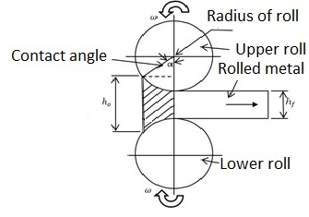
Forging is a bulk forming process in which the work piece or billet is shaped into finished part by the application of compressive and tensile forces with the help of a pair of tools called die and punch. Forging can be done in open dies or closed dies. Open die forging is usually used for preliminary shaping of raw materials into a form suitable for subsequent forming or machining.
Closed die and open die forging

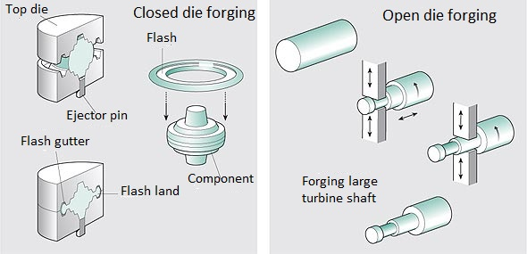

Open die forging is done using a pair of flat faced dies for operations such as drawing out, thinning, etc.
Closed die forging is performed by squeezing the raw material called billet inside the cavity formed between a pair of shaped dies. Formed products attain the shape of the die cavity. Valve parts, pump parts, small gears, connecting rods, spanners, etc. are produced by closed die forming.
Coining is the process of applying compressive stress on surface of the raw material in order to impart special shapes on to the surface from the embossing punch – e.g. coins, medallions.
Extrusion involves forcing the raw material through a narrow opening of constant cross-section or varying cross-section in order to reduce the diameter and increase the length. Extrusion can be done hot or cold. Extruded products include shafts, tubes, cans, cups, gears.
Basically there are two methods of extrusion, forward and backward extrusions. In forward extrusion the work and the extrusion punch move along the same direction. In backward extrusion the punch moves opposite to the direction of movement of the work piece.
Direct and indirect extrusion
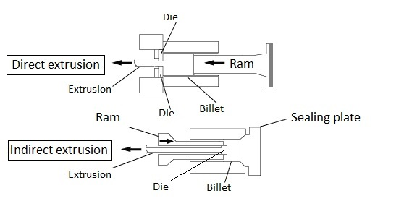
Wire drawing process is used for producing small diameter wires from rods by reducing their diameter and stretching their length through the application of tensile force. Musical strings are produced by wire drawing process. Seamless tubes can be produced by tube drawing process.
Wire drawing
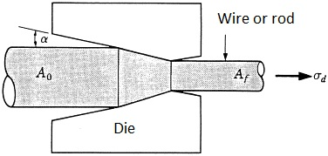

B. Sheet metal operations
Deep drawing is a sheet metal process; the process in which a sheet metal is forced into cup of hollow shape without altering its thickness – using tensile and compressive forces. Complex shapes can be produced by deep drawing of blanks in stages – redrawing, multiple draw deep drawing etc.
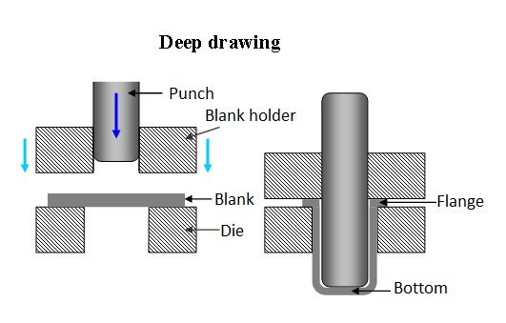
Hydro mechanical deep drawing uses both punch force and hydrostatic force of a pressurized fluid for achieving the shape.
Flanges and collars are formed by flanging process.
Spinning transforms a sheet metal into a hollow shape by compressive and tensile stresses. Spinning mandrel of given shape is used against a roll head.
Shearing and bending
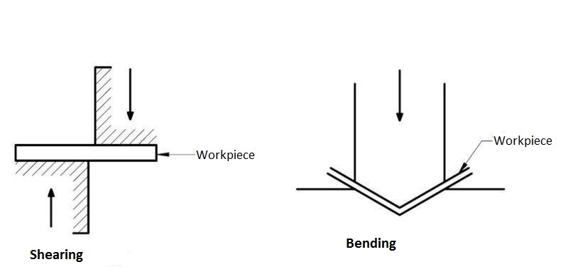
Embossing imparts an impression on the work piece by means of an embossing punch.
Bending of sheets includes rotary bending, swivel bending, roll bending using rotary die.
Die bending using flat die or shaped die is used for bending of sheets, or die coining of sheets.
TASKS
7.1. Answer the following questions.
1. How do you define rolling? 2. Can rolling be carried out in hot or cold conditions? 3. Is the work piece or billet shaped into finished part in forging? 4. What is the difference between rolling and forging? 5. What process uses a pair of flat faced dies for operations such as drawing out, thinning, etc? 6. What articles are produced by closed die forming? 7. For what purpose is compressive stress on surface of the raw material applied in coining? 8. What is the essence of extrusion? 9. What are the two methods of extrusion? 10. What happens while deep drawing?
7.2. Match words or word combinations with their definitions.
1. deep drawing  2. rolling  3. forging  4. coining  5. die  6. workpiece  7. punch  8. extrusion process  9. wire drawing  10. blank | a) a process in which the work piece or billet is shaped into finished part by the application of compressive and tensile force;  b) forcing heated alloy billet through a die by pressure;  c) the process of applying compressive stress on surface of the raw material;  d) a metal block used in forming materials;  e) a metal forming process in which metal stock is passed through one or more pairs of rolls to reduce the thickness and to make the thickness uniform;  f) the fabrication process of flat rolled steel to make drawn parts;  g) the moveable die in a press or forging machine;  h) a piece of stock (also call a slug or multiple) from which a forging is to be made;  i) a piece of work in process of manufacture;  j) producing wires from rods.

7. 3. Complete the following statements by choosing the answer which you think fits best. Are the other answers unsuitable? Why?
1. In forging the work piece or billet is shaped into:
a) finished part;
b) semi-finished part;
c) blank.
2. Open die forging is usually used for:
a) producing parts very near to final dimensions with minimum material wastage;
b) preliminary shaping of raw materials into a form suitable for subsequent forming or machining;
c) forming which have low surface area to volume ratio.

3. Valve parts, pump parts, small gears etc. can be produced by:
a) closed die forging;
b) open die forging;
c) coining.
4. The work and the extrusion punch move along the same direction in:
a) wire drawing;
b) backward extrusion;
c) forward extrusion.
5. When we need complex shapes we use:
a) deep drawing;
b) direct extrusion;
c) open die forging.
7. 4. Insert the missing words using the table below.

forming | flow | drawing | blank | blank dimensions

The essential prerequisites for achieving optimal work results in deep (1)_____ are the correct control of the material (2)_____, the determination of the (3)_____, the knowledge of the limits to which the (4)_____ can be driven within a single operation and the estimation of the force required to shape the (5)_____.
7.5. Change the underlined words using their equivalents given in the table.

induce | collapse | produced | coarseness | worked

If the surface of the workpiece to be (1) processed exhibits marked pores or high (2) roughness heights, such as those found in cast iron, a lubricant may not be used, as the lubricant entering the pores can (3) cause changes to the loading condition of the workpiece possibly leading to (4) failure as a result of the hydrostatic pressure (5) generated during rolling.

7. 6. Match words from two columns to form a term or word combination used in Texts A and B.
1. sheet  2. deep  3. backward  4. tensile  5. hollow  6. open die | a) extrusion  b) drawing  c) shape  d) forging  e) metal  f) force

Over to you
Think of an enterprise you are familiar with. Describe specific aspects of it: the type of equipment it uses, the forming operations used for producing specific shapes, the finished products it produces.

UNIT 8

ROLLING MILL PRACTICE

A: The rolling process is a process of working the metal by compression. Passing between two rolls revolving in opposite directions but at the same surface speed, the metal assumes the dimensions required. The rolls are arranged so that the distance between them is less than the thickness of the metal fed. The rolls grip the material and deliver it reduced in thickness, increased in length and probably somewhat increased in width. This is one of the most widely used processes among all the metal working processes, because of its higher productivity and lower operating cost. Rolling is able to produce a product which is having constant cross section throughout its length. Many shapes and sections are possible to roll by the steel rolling process.
B: Major parameters in the three stages of mill processing are as follows:
- Reheating – The input material usually billet is heated in the reheating furnace to the rolling temperature. The important parameters are heating rate, time of heating, and temperature of reheating.
- Rolling – The important parameters for rolling in the roughing, intermediate, and finishing group of stands in the rolling mill are temperature, percentage of reduction in area, inter-pass time and strain rate.
- Cooling – The major parameters after finish rolling during cooling of the rolled product are start temperature, cooling rate and the final temperature.

C: The rolls may be plain as those used for rolling slabs, plate and sheet, or grooved, as those used for rolling billets, bars and sections. The roll, made of steel or cast iron, has the following parts: (1) the “body” on which the rolling is accomplished, (2) two “necks” on which the roll revolves in the bearings, and (3) the “wobbler”, a star-shaped coupling, though which the roll is driven.
The roll stand comprises two housings erected on the bed plates and joined together by separators or tie-rods, chocks bearings of the rolls and devices for adjusting the rolls.
They commonly employ 2-high, 3-high and 4-high roll stands. The 2-high non-reversing roll stand has two rolls with a constant direction of rotation. In the 2-high reversing roll stand, the rolls rotate first in one direction and then in the other so that the rolled metal passes back and forth through the rolls several times.
The 3-high roll stand has three rolls with a constant direction of rotation. In some cases the middle idle roll is of smaller diameter than the other two. During rolling, the middle roll is held against and rotated by either the top or bottom roll. The application of a small-diameter middle roll increases the amount of elongation and decreases the required lift of the rolled metal for passing through the idle and top rolls.
The 4-high roll stand has four rolls arranged in a vertical plane. The two smaller in diameter are working rolls while the larger are back-up rolls. The back-up rolls support the working rolls in operation and reduce their elastic deflections.
The rolling mill may consist of either one roll stand as the cogging mills (blooming or slabbing mills) or a number of stands.

D: The rolling process comprises two stages: (1) rolling the ingot into the semi-finished products, namely, blooms, billets and slabs; and (2) rolling the semi-finished product into the finished products, such as wire, rails, bars, sections (from the blooms and billets), plate, sheet (from the slabs).
The primary object of rolling is the breakdown of a coarse structure of the metal under operation, which makes it stronger.

E: The breaking – down department, producing semi-finished products, may contain only a blooming mill or a blooming mill and a continuous billet mill which is located adjacent to it. This arrangement enables small billets to be rolled from heavy ingots in a single heating.
The slabbing mill is the chief breaking down mill in plants designed for the large-volume production of plate (over 4mm thick) and sheet (up to 4 mm thick). The advantage of the slabbing mill in comparison with the blooming mill is that former has two vertical rolls in addition to its horizontal rolls. This enables the width to be rolled without turning the ingots on edge.

F: The main requirements in rolling are: (1) to obtain a finished product at the highest possible rate of production and the lowest cost, (2) to obtain a finished product at the highest quality concerning not only its physical and mechanical properties, but also its surface condition. These requirements may be met only if the processing schedule for all operations in producing the given rolled product is strictly followed. These operations are (a) preparing the initial material for rolling, which consists in the removal of various surface defects, (b) heating the initial material before rolling either in the soaking pits (for ingots) or in the heating furnaces (for blooms and slabs), (c) rolling, (d) finishing, including cutting, cooling, etc.
If it is not observed, the rolled product obtained may have defects such as flakes or cracks or may have unsatisfactory properties.
TASKS
8.1. Match the following terms with their definitions.

1. slabbing mill | a) metal in the form of thin sheet up to 4 mm;
2. blooming mill | b) a piece of semi-finished iron or steel nearly square in section made by rolling an ingot or bloom;
3. cogging mill | c) a rolling mill in which blooms are produced from ingots in steel manufacture ;
4. billet | d)pair of heavy rolls through which heated steel ingots are passed
5. plate | e) a steel rolling mill that produces slabs;
6. sheet | f) forged, rolled, or cast metal in sheets usually thicker than ¹/₄ inch (6 millimeters).

8.2. Replace the underlined expressions in the report extract with alternative words and expressions from texts A and B.

Steel rolling consists of passing the material, usually termed as rolling stock, between two rolls (1) driven at the same peripheral speed (2) one clockwise and the second anti-clockwise and so (3) spaced that the distance between them is somewhat less than the thickness of the(4) section entering them.

Now we know the primary role of hot rolling mills, which is to produce (5) the cross-sections of steel at different dimensions. During this process billets of steel are used. In short, the whole process involves using steel that passes through rolling mills (6) at increased temperature. The method reduces the thickness of the steel and forms into required shape as per the requirement.

8.3. Complete a structural engineer's description using the words in the box.

final product | internal defects | edge cracks | rust | surface

Defects in Metal Rolling
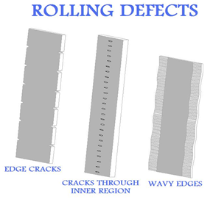
A wide variety of defects are possible in metal rolling manufacture. (1) ……… defects commonly occur due to impurities in the material, scale, (2) …….. , or dirt. Adequate surface preparation prior to the metal rolling operation can help avoid these. Most serious (3) …….. …….. are caused by improper material distribution in the (4) ……. …….. . Defects such as (5) …….. …….. , center cracks, and wavy edges, are all common with this method of metal manufacturing.

8.4. Decide whether the sentences below are true or false, and correct the false sentences. Look at text to help you.
1. The rolling process comprises rolling the ingot into the finished products.
2. The blooming mill has two vertical rolls in addition to its horizontal rolls.
3. During Hot Rolling, the coarse-grained, brittle, and porous structure of the continuously cast steel is broken down into a wrought structure having finer grain size and improved properties.
4. The stands are grouped into roughing, intermediate and finishing stages.

5. Steel rolling consists of passing the material, usually termed as rolling stock, between two rolls driven at the same peripheral speed in opposite directions

8.5. Give the grounds for these statements.
1. The rolls are arranged so that the distance between them is less than the thickness of the metal fed.
2. The primary object of rolling is the breakdown of a coarse structure of a metal.
3. The rolling department may contain a blooming mill with a continuous billet mill, which is good practice from the economical point of view.
4. Strict observance of the prescribed conditions for heating the metal before rolling and cooling it after rolling is very significant.

Over to you.
Think about the specific types of rolling processes that are used in your industry, or industry you’re familiar with. How are they used? Give examples of types of loads which act on specific components or members. How would the different components or members deform or fail if they were not adequately designed, or if they were overstressed?

APPENDIX
MATHEMATICAL SYMBOLS
Symbol | Example | Meaning in full
. | 3.14 | thee point one four
+ | a +b | a plus b
- | c-d | c minus d
= | T=24 | T equals twenty four
x | 3x10 | three multiplied by ten / three times ten
: | 16:8 | sixteen divided by eight
% | 10% | ten per cent
° | 20° | twenty degrees
> | > 10 | greater than ten
< | < 20 | less than twenty
≤ | ≤ 12 | less than or equals to twelve
≥ | ≥ 30 | greater than or equals to thirty
√ | √16 | the square root of sixteen
n³ | 10³ | ten to the power of three
{} |  | curly brackets
[] |  | square brackets
() |  | round brackets
∞ | A ∞ B | A is proportional to B

CONVENTIONAL METRIC UNITS
Name | Multiplication | Symbol
nano | 10ˉ⁹ | n
micro | 10ˉ⁶ | ͘ µ
milli | 10ˉ³ | m
kilo | 10³ | k
mega | 10⁶ | M
giga | 10⁹ | G
tera | 10¹² | T

METAL FORMING GENERAL TERMINOLOGY
Common terms and their definitions
Component | Function
forging | manufacturing process in which a piece of (usually hot) metal is formed into the desired shape by hammering, pressing in one or more forging equipment
rolling | metal shaping process in which a billet is repeatedly passed between hard rolls to get a desired shape, thickness, and surface finish
extrusion | manufacturing process in which a billet is forced through a shaped metal piece or die to produce a continuous ribbon of the formed product
drawing | process of pulling a metal bar, rod, or wire through the hole of a die to alter its finish, shape, size, and/or mechanical properties
stress | load (force) per unit area that tends to deform the body on which it acts. Compressive stress tends to squeeze a body, tensile stress to stretch (extend) it, and shear stress to cut it
strain | measure of the extent to which a body deforms under stress
mechanical properties | characteristics that indicate the elastic or plastic behavior of a material under pressure (force), such as bending, brittleness, elongation, hardness, and tensile strength.
tensile strength | resistance to elongation, the maximum longitudinal stress a material can bear with fracture or permanent deformation
yield strength | load at which a material deforms permanently without increase in the load
equipment | tangible property (other than land or buildings) that is used in the operations of a business. Examples of equipment include rolling mills, machines
tool | An item or implement used for a specific purpose. A tool can be a physical object such as mechanical tools including mill rolls and hammers

SI UNITS FOR METAL FORMING
Name | Unit | Symbol
time | second | s
length | metre | m
mass | kilogram | kg
force | newton | N
pressure, stress | pascal | Pa
energy, work | joule | J
power | watt | W
temperature | degree Celsius | °C
speed, velocity | metre per second | m/s
angular velocity | radian per second | rad/s
area | square metre | m²
volume | cubic metre | m³
moment of force | newton metre | N⋅m
density | kilogram per cubic metre | kg/m³
moment of inertia | kilogram square metre | kg⋅m2

STRUCTURAL SECTIONS
I | Universal beam (UB) an I-section with a depth greater than its width
L | Rolled steel angle (RSA) an L-section
T | Structural tee a T-section
O | circular hollow section (CHS) a circular tube
[ | rolled steel channel (RSC) a C-section

ЛІТЕРАТУРА

- Ibbotson Mark. Professional English in Use. Engineering. Technical English for Professionals. – Cambridge University Press, 2009. — 144 p.
- Ibbotson M. Cambridge English for Engineering: Professional English.– Series Editor: Jeremy Day, Cambridge University Press, 2011 – 107 p.
- Brieger Nick, Pohl Alison Technical English. Vocabulary and Grammar. – Summertown Publishing, 2006. — 148 p.
- Sopranzi S. Flash on English: Mechanics, Electronics and Technical Assistance. – ELI, 2012. — 50p.
- Parsons R. GCSE AQA Physics. Complete Revision and Practice. – Newcastle upon Tyne, 2011 – 236 p.
- E.P. Kononenko, V.I. Meleshko English for Metallurgical Students. – Киев, «Вища школа», 1984 – 176 с.
- NPTEL - Mechanical Engineering – Forming [Електронний ресурс] . – Режим доступу: http://www.idc-online.com/technical_references/pdfs/mechanical_engineering/Fundamental_concepts_of_metal_forming.pdf
- BusinessDictionary [Електронний ресурс] . – Режим доступу: http://www.businessdictionary.com

ЗМІСТ
Стор.
ВСТУП 3
UNIT 1 ENGINEERING - WHAT’S IT ALL ABOUT? 4
UNIT 2 FORMING, WORKING AND HEAT-TREATING METAL 7
UNIT 3 LOAD, STRESS AND STRAIN 10
UNIT 4. FORCE, DEFORMATION AND FAILURE 14
UNIT 5. METAL FORMING PROCESSES 17
UNIT 6. METAL FORMING OPERATIONS. CLASSIFICATION 22
UNIT 7. METAL FORMING OPERATIONS. BRIEF DESCRIPTION OF
FORMING OPERATIONS 26
UNIT 8. ROLLING MILL PRACTICE 33
APPENDIX 38
ЛІТЕРАТУРА 41

Навчальне видання

Нікітіна Ірина Петрівна
Кирпита Тамара Володимирівна
Бояркін Вячеслав Володимирович

ENGLISH FOR METAL FORMING

ENGINEERING.

Навчальний посібник

Тем. план 2019, поз. _____

Підписано до друку _______. Формат 60х84 1/16. Папір друк. Друк плоский.
Облік.-вид. арк. ____. Умов. друк. арк. _____. Тираж 100 пр. Замовлення № __.

Національна металургійна академія України
49600, м. Дніпро-5, пр. Гагаріна, 4
_______________________________
Редакційно-видавничий відділ НМетАУ

